Atomic Structure Assignment – Validation Test
Name:
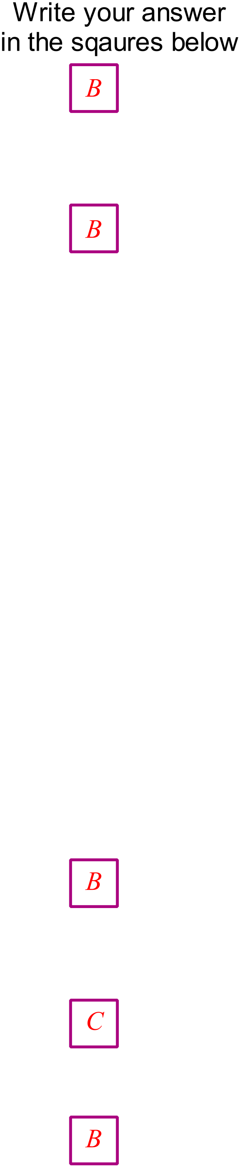 /35
- Which of the following represents a chromium (III) ion with 28 neutrons?
  - 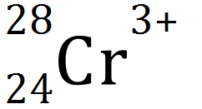
  - 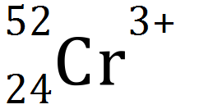
  - 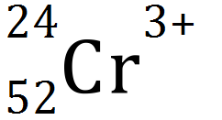
  - 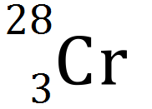

- Which one of the following species does not have an electron configuration of 2,8?
  - Ne
  - F⁻
  - Na
  - O²⁻

- The successive ionisation energies for an element, Y, are shown below.

Equation for process | Ionisation Energy  (kJ mol⁻¹)
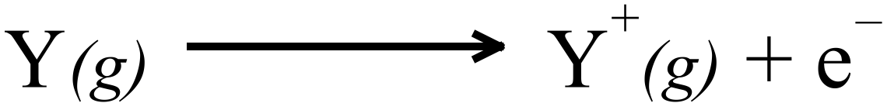 | 1000
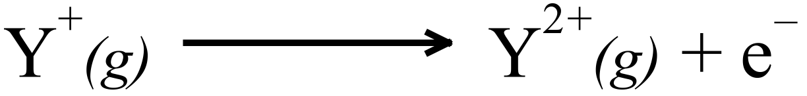 | 2252
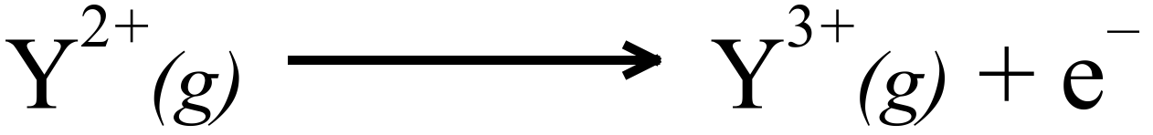 | 3357
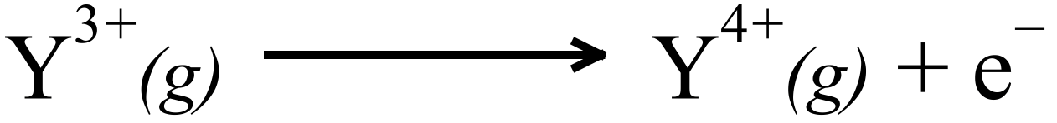 | 4556
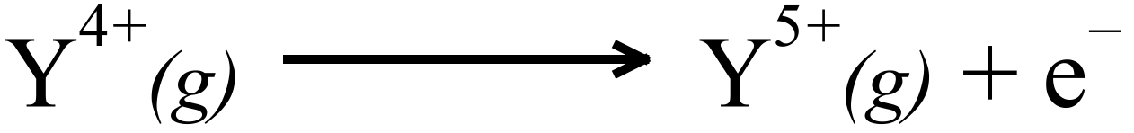 | 7004
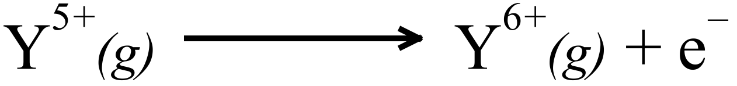 | 8496
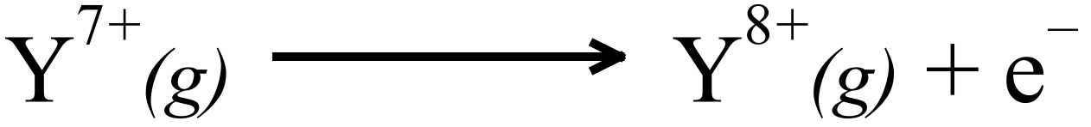 | 27107
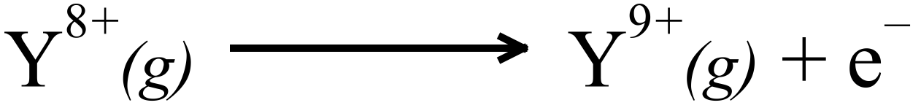 | 31719
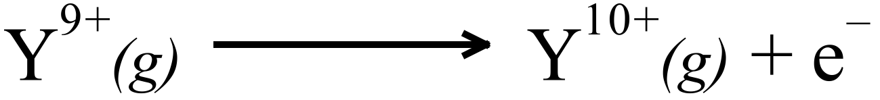 | 36621
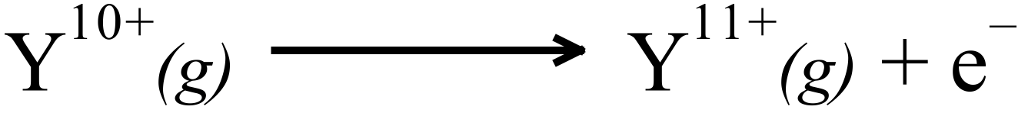 | 43177
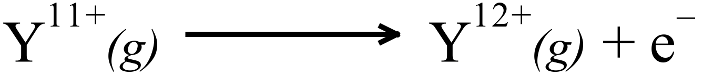 | 48710
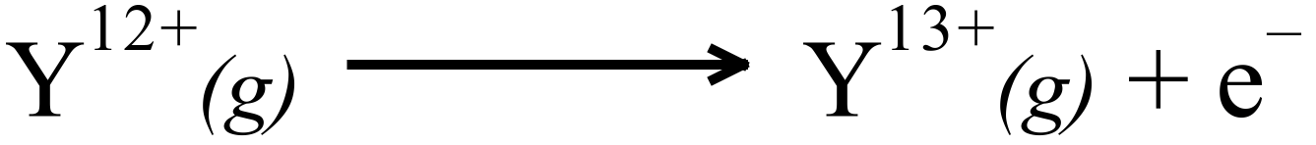 | 54460

The element is most likely to be Y is…
  - Oxygen
  - Sulphur
  - Chlorine
  - Phosphorus

- Which of the following has the greatest core charge?
  - An aluminium atom
  - A chlorine atom
  - A magnesium ion
  - An oxide ion

- Which of the following statement about Group 1 metals is untrue?
  - 1 electron is present in the valence shell of the metal.
  - Their chemical reactivity decreases with atomic number.
  - Their +1 (positive) ions have noble gas configuration.
  - Their core charge is constant.
- Complete the following statements:
  - Ionisation energy increases across the periodic table because… (2)

A greater number of protons causes an increase in attraction for valence electrons. (1)

More energy is the needed to remove a valence or outer shell electrons. (1)
  - Ionisation energy decreases down groups in the periodic table because… (2)

There is less proton-electron attraction as atoms increase in size (radius). (1)

Outer electrons are further from a positive nucleus as so can be more easily removed. (1)

- For each of the following pairs of atoms explain which has the larger atomic radii:

  - A Nitrogen atom or an Oxygen atom (2)
The nitrogen atom, due to lower number of protons attracting the electrons.

  - A Chlorine atom or a Bromine atom (2)
The Bromine atom, due to the greater number of electron shells.

  - A Magnesium atom or a Magnesium ion (2)
The magnesium atom, due to the greater number of electron shells.

- List four different species that have the electron configuration of 2,8. (2)

Ne Cl⁻ O²⁻ Na⁺ Mg²⁺
- Five elements and their electronic configurations are as follows:
Na: 2,1 Mg: 2,2 He: 2 O:2,6 S:2,8,6
- In a chemical reaction which element is most likely to: (3)
    - Gain 2 e⁻? O
    - Lose 2 e⁻? Mg
    - Not react? He
- Which element(s) form: (3)
    - Covalent bonds? O & S
    - Metallic bonds? Na & Mg
    - Forms a diatomic element? O
- Which element: (2)
          - Is the most reactive? Na
          - Has the smallest radius? He

- A plot showing the successive ionisation energies of Magnesium is given below.

- Define ionisation energy. (1)
The energy required to remove each successive electron (same core charge applied to them)

- Explain the gentle increase between the first and second ionisation energies for magnesium (1)
Both electrons are removed from the outer shell.

- Explain the significant increase in moving from the second to the third ionisation energy for magnesium. (1)
The third electron is removed from the next shell (second most outer shell).

- Explain the gentle increase between the third and tenth ionisation energies for magnesium (1)
All electrons are from the same electron shell (same core charge applied to them)

- On the chart above indicate where you would expect the eleventh and twelfth ionisation energies for magnesium to be. (1)
As shown above: 11th (160-180) 12th (180-200)
- Explain your reason for this location. (1)
These electrons are from the next inner most shell, have a higher core charge and are closer to the nucleus.

- On the same axes above, sketch (and label) the graph you would anticipate for the first eight successive ionisation energies of calcium. (1)
All points should be lower, but follow a similar trend (pattern).
- On the same axes above, sketch (and label) the graph you would anticipate for the first eight successive ionisation energies of sodium. (1)
The first should be lower, then a significant increase to the second, gentle increase from second to eighth.
- Explain the position of the graphs for magnesium and sodium. (2)
Calcium has two valence electrons, so will follow the trend of Magnesium, but with more shells, the distance to the electrons is greater so the force holding them in is lower, so the ionisation energy will be less.
Sodium has 1 valence electron, so there is a significant increase from the first to the second.

